Cloud computing is the use of a network of remote servers hosted on the internet to store, manage and process data rather than local server.

* Pay for what you use
* It is the delivery of computing services(servers, databases, networking , software etc) over the internet.
* In simple terms, it means storing or accessing your data over internet.

Why Cloud Computing?

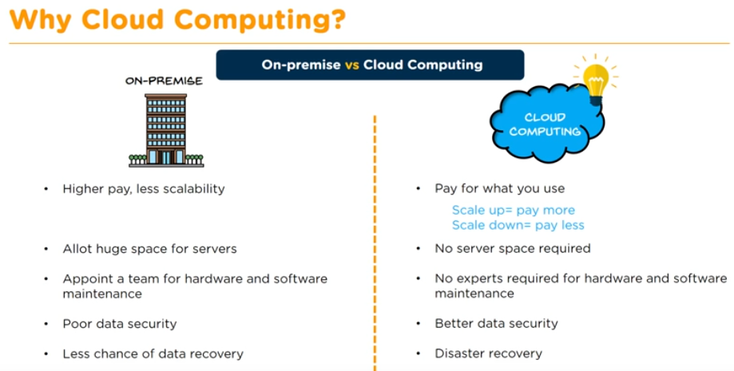

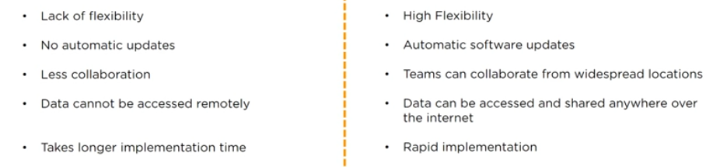

Service Providers:

Cloud Computing service providers give the ability to manage applications and services through a global network.

Example: AWS, Azure etc.

Features:

* Speed
* Cost
* Scalability
* Accessibility
* Better Security

Types of Cloud Computing

1. Cloud deployment: public, private, hybrid cloud
2. Cloud Services: Iaas, Paas, Saas

Public Cloud:

* Here, the Services are stored off-site and accessed over the internet.
* It can be used by general public
* All hardware, software and other supporting infrastructure is owned and managed by cloud provider.

Private Cloud:

* The cloud infrastructure is used exclusively by a single organization.
* The organization may run its private cloud or outsource it to a hosting company.
* The services and infrastructure are maintained on the private network.

Hybrid Cloud:

* It consists the functionalities of both public and private cloud.

Infrastructure as a Service (IaaS):

* You rent IT infrastructure (server and network etc) from a cloud provider as a pay-as-you-go basis
* Users of IaaS can outsource and build a “virtual data center” in the cloud and have access to the resources as well
* Example: AWS Elastic Compute Cloud(EC2).

Platform as a Service (PaaS):

* Provides a platform on which software can be developed and deployed.
* The cloud provider allows the customer to deploy their own application using programming language, tools etc.
* Example: AWS Elastic Beanstalk

Software as a Service (SaaS):

* Cloud providers host and manage the software application as subscription basis.
* Client maintains the control of a software environment but does not maintain any equipment.
* Example: Amazon Web Service

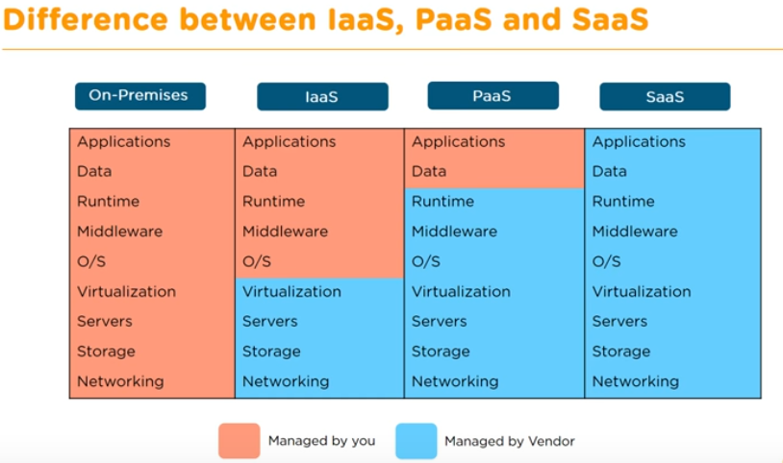

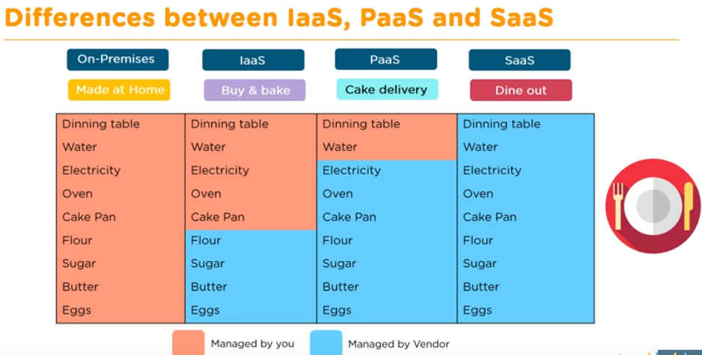

AWS:

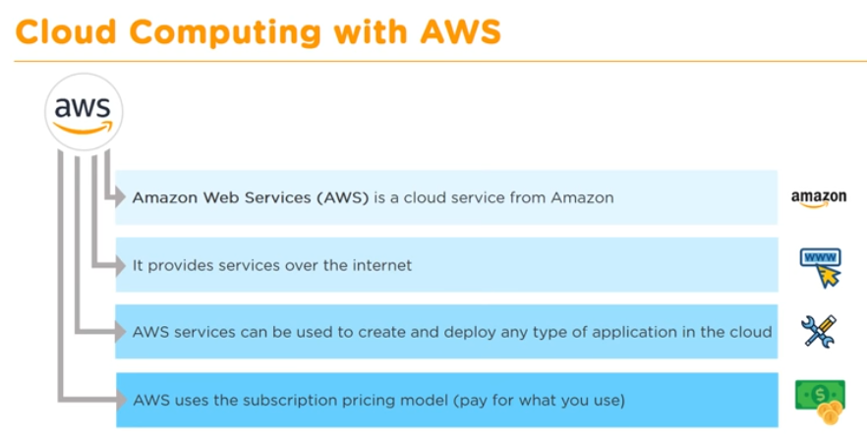

AWS is a secure cloud services platform. With the Pay-as-you-go system, there is no requirement for upfront capital. Available in matter of seconds. Helps in controlling auditing and managing identity, configuration and usage. Easily available when required . Offers nearly 100 cloud applications with features.

Life Cycle of a cloud computing Solution:

* Define the purpose: Understand the requirement of the business and determine what type of applications to run on the cloud.
* Define the Hardware: Choose a compute service that will provide the right support where you resize the compute capacity in the cloud to run application programs. Ex: EC2, Lambda, Elastic container Service.
* Define the storage: Choose a storage service where you can backup and archive your data over the internet. Ex: S3, EFS, Glacier
* Define the network: Define a network that securely delivers data, videos ,application etc with low latency and high transfer speed. Ex: VPC, Route 53, Direct connect.
* Define the Security: Set up your security service which enable services for under authentication or limiting access to a certain set of users on your AWS resources. Ex: IAM, KMS, Cognito.
* Define Management Processes and tools : You can have complete control on your cloud environment by defining management tools which monitor AWS resources and customer applications running on AWS platform. Ex: cloudWatch, Auto scaling and CloudFormation.
* Testing the process: Verify the process using AWS developer tools where you can build, test and deploy your code quickly. Ex: CodeStar , codeBuild , codePipeline.
* Analytics: Finally, analyze and visualize data by using analytics services where you can start querying data instantly and get results. Ex: Athena, EMR, CloudSearch